Weight Controlled Dry Goods Dispenser

# What?

The idea is to build a dispensing system for dry goods, like something I saw in an industrial setting for measuring out powder supplements like creatine. Using the correct amount of ground coffee makes for a better cup and saves money. I want to be able to dispense the ground coffee onto a scale until it reaches a predetermined weight and then programmatically engage a mechanical stop on the dispenser. I want the weight to be easily entered in either standard or metric and the current weight and dispensing weight visible on an LCD. For this project the scale used will need to be accurate between 0-1 oz.

# How?

I see four parts to this, the dispenser, the scale, the input panel, and the control (Arduino Uno)

### Dispenser

For the dispensing portion I looked into kitchen gadgets and industrial solutions for dispensing fine-grained or powdered chemicals. I saw several approaches, Some involved a sliding latch under a bin like a powder horn, others have a rotating flipper, the best, most accurate design I saw involved an screw that drew small amounts of material from the hopper by rotating inside a tube with opening under the material hopper and over the weighing mechanism.

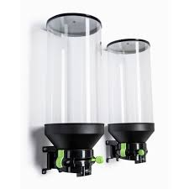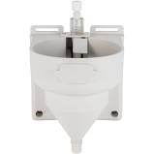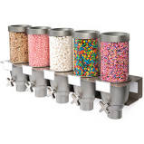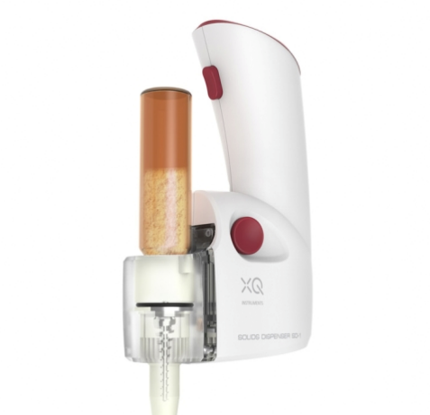

I am going to try and replicate the screw dispenser with a servo motor, a screw (not sure about that yet, I am going to Menards for inspiration) and some small diameter PVC tubing. The servo only needs power, ground and a digital pin. There may be other mechanical difficulties such as material not exiting the machine, I have seen vibrating motors attached to the system to loosen stuck material with short pulses.

### Scale

For the scale portion, I am going to use the HX711 AD Converter with Breakout module, according to its spec sheets it will be sensitive enough for this project. “Accurately measures forces from 0-5kg\0-11lb” the hookup for this is pretty simple, in needs power, ground and two digital pins

### Input

For the input portion I portion I might just go with a pc interface built over some Processing sketch to communicate through input strings to the serial monitor. The strings might go something like “0,2,29” or 0 = metric, 2 = two decimal places or X * .01, and 29 units of whatever, e.g. “dispense .29 grams of material”

### Control

The Arduino sketch should be straightforward, take an input from the user, run the servo until the scale contains the desired amount and then fire an interrupt to stop the servo. I imagine the servo will need to be stopped some time before the scale hits the exact weight to account for the weight of material still coming out of the dispenser as it stops. There should also be the feature to just run the servo\dispenser, like a set of buttons that runs the servo forward or backward.